Andrew Taylor-Shaut

Advanced Mobile Application Development; Project 1

Aileen Pierce

26 February 2017

Profile

**Milestone 1**

I want to create an app that applies collection and table views we have used to create a multiply tabbed home page that segues to different views that present different information. This app will allow the user to store their profiles as well as other information they want one this collection of information. The intended audience is people who have multiple social networks and other information that they want to combine on one hub for easier access.

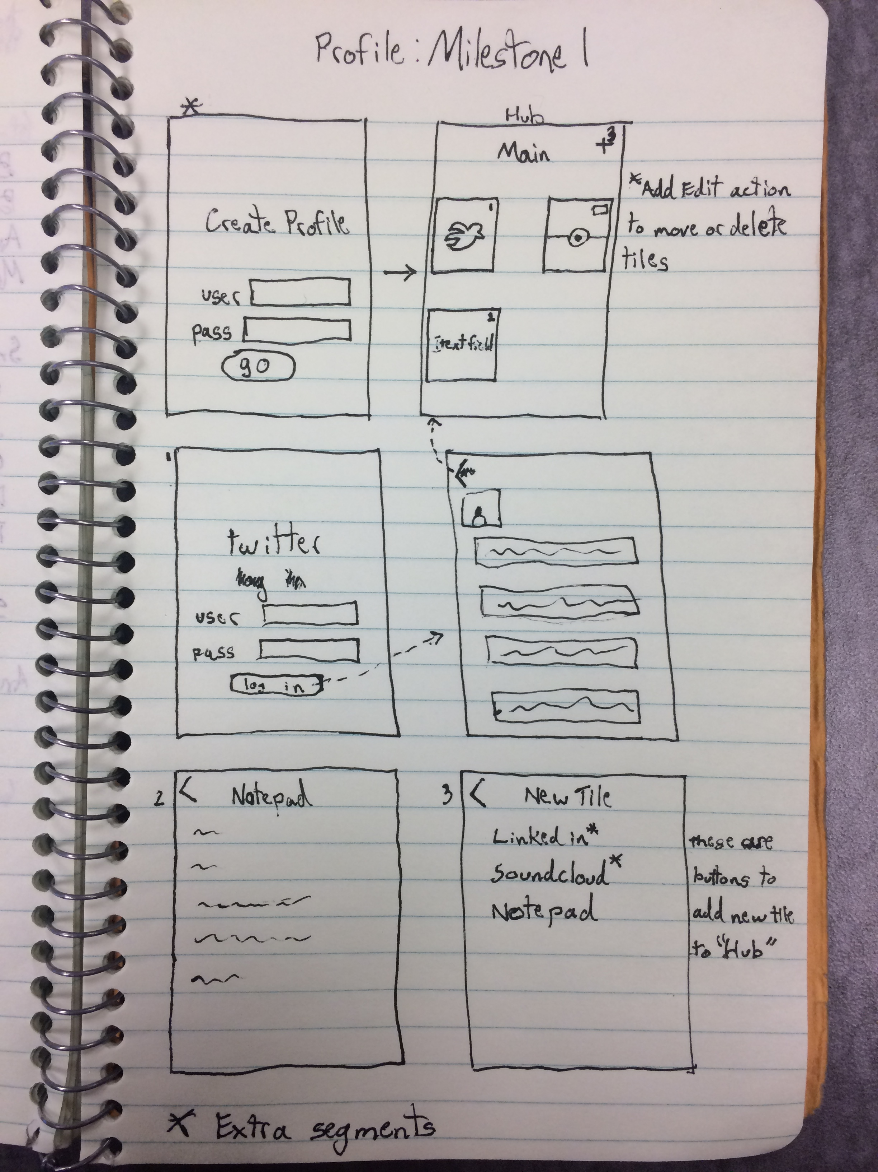

**Milestone 2**

The steps to designing this are to create a navigated initialized collection view. The collection view has multiple preset cells that all buttons that link to different views that contain separate information. A cell would prompt you to log in to a specific social network, if that is the cell option you choose, or a blank view that could be an editable table view or text field. I will need to allow this information to be saved so that the user can continue to use the app where they left off as opposed to starting over every time they open it.

I plan on using internet searched directions as to how to allow users to access their social network pages. The first targeted ones are Twitter and Instagram feeds.

Although we do not learn firebase until after this project is due I will try to enable the user to store their data by creating a profile. I would need to find a tutorial if the site does not explain the necessary steps or intuitive enough.

I hope to get to a point where the user selects the option to add a new collection cell and in their choices of a new cell they can choose from other forms of social media as well as a blank table view or text field. This would be an extension off the idea of storing a picker view with dependent information. It would then have the certain preset cells that I would set to be shown at the collection view’s viewDidLoad. I would need to code in that these collection cells are not opened until their designated cell button is pressed, so that the preset social media feeds do not automatically ask the user to sign in as well as when new picked social media feeds are not automatically opened and presented with the option to log in.